**Contents**

NOTES: 2

7 Feb 2023 Immersification Stream for CSD3120 3

Setup Skybox 3

Configure Skybox Texture (Part 1) 7

Download Skybox [OPTIONAL] 9

Configure Skybox Texture (Part 2) 11

Setup Camera 14

Setup Lights (HemisphericLight) 17

Setup Lights (PointLight + HeimisphericLight) 20

Setup VideoSkyDome (alternative to Skybox) 23

Where to get free 360 videos (to test) 27

Adding Inspector Keyboard Shortcut 28

Handling window resize 32

Setup Models 33

Setup Animation 39

Setup Particles 44

Setup Sounds 50

Create Button (with clicking sound) 55

# NOTES:

- If you haven’t done Part 1 yet, here’s the link to [Part 1](IPAsetup_part1.docx)

- If you haven’t done Part 2 yet, here’s the link to [Part 2](IPAsetup_part2.docx)

**TOPICS COVERED:**

**INSTALLING DEPENDENCIES:**

**FINAL CHANGES:**

webpack.config.js

tsconfig.json

# Developing Immersive Applications: Recorded live coding stream on "Implementing Interactions"

<https://www.youtube.com/watch?v=8zXOif9Ys8c>

## Installing plugins

Enter the following commands in WSL:

npm i copy-webpack-plugin -D

You should be able to see "copy-webpack-plugin" added to your "devDependencies"

**webpack.json**

Add the following codes:

const CopyPlugin = require('copy-webpack-plugin')

Here:

Add the following codes:

new CopyPlugin({

            patterns: [

                { from: path.resolve(__dirname, 'public')}

            ]

        }),

Here:

Enter the following commands in WSL (to Rebuild the project):

npm run build

You should be able to see your assets folder from your public folder copied to your dist folder.

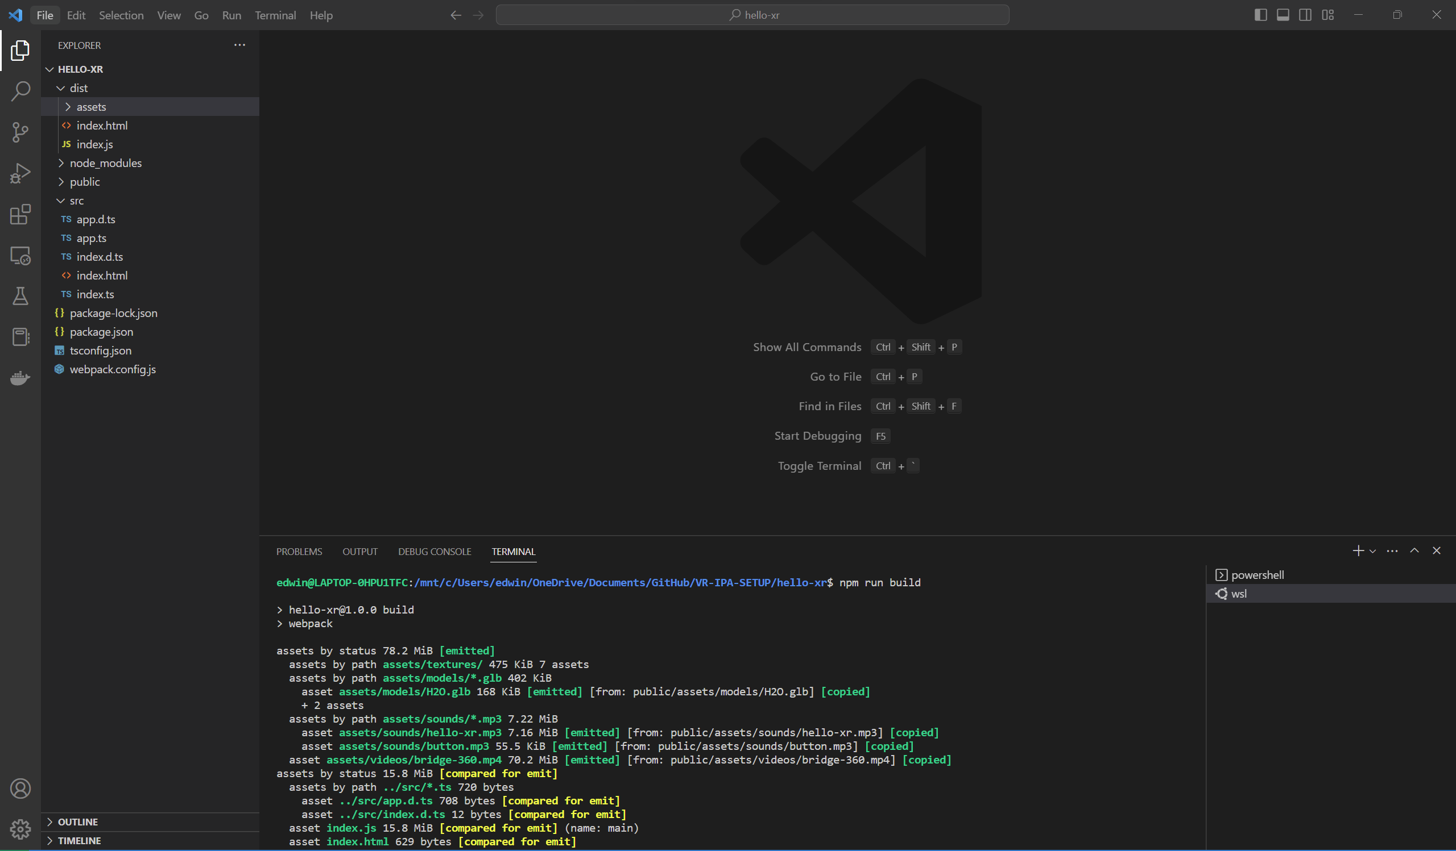

## Deploying to Production Server (instead of Dev Server)

Enter the following commands in WSL:

cd dist

python3 -m http.server

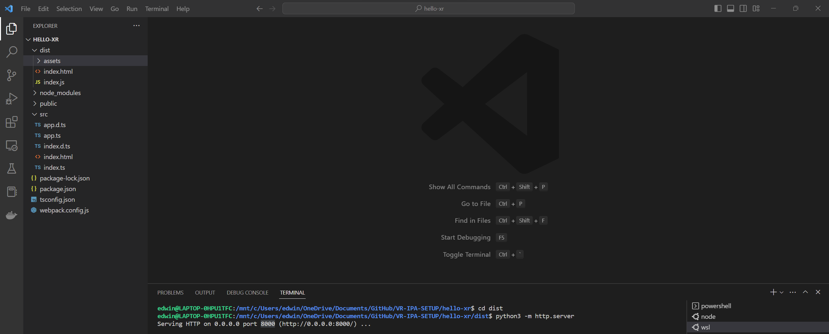

Go to localhost:8000 in your chrome browser.

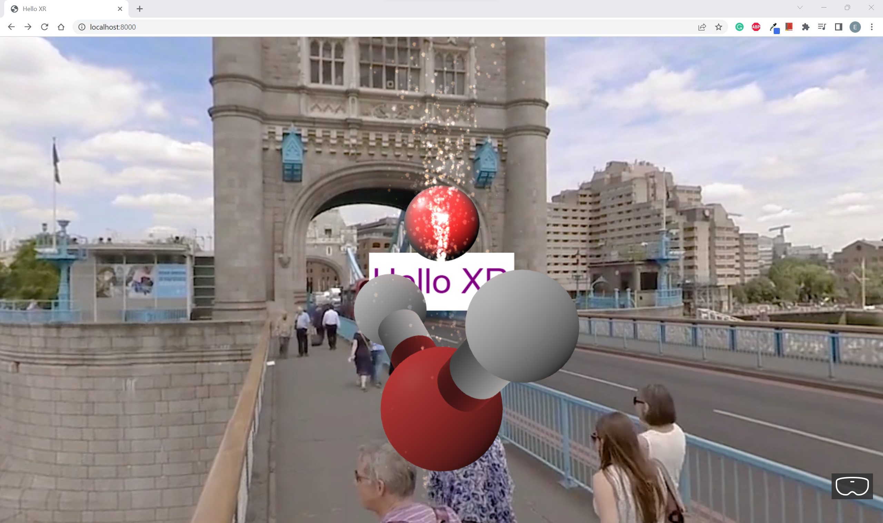

You should be able to see the Web App working fine on the production server.

## Refactoring codes

**tsconfig.json**

Comment out the following codes:

//"declaration": true,

Here:

**app.ts**

Under createScene():

Comment out the following codes:

//this.createVideoSkyDome(scene);

//this.addSounds(scene)

Change this code to:

sphere.position.y = -0.5

Change these codes to:

scene.createDefaultCameraOrLight()

//this.createCamera(scene)

//this.createLights(scene)

*Component based architecture*

### Text Component

Enter the following commands in WSL:

cd src

mkdir -p components/meshes

cd components/meshes

touch index.ts

touch text-plane.ts

You should be able to see "components\meshes" folders added to your "src" folder.

Go to **components\meshes\index.ts** and add the following codes:

export * from './text-plane'

Go to **components\meshes\text-plane.ts** and add the following codes:

import { Mesh, MeshBuilder, Scene } from "babylonjs";

import { AdvancedDynamicTexture, TextBlock } from "babylonjs-gui";

export class TextPlane {

  public mesh: Mesh

  public textBlock: TextBlock;

  constructor(

    name: string,

    width: number,

    height: number,

    x: number,

    y: number,

    z: number,

    text: string,

    backgroundColor: string,

    textColor: string,

    fontSize: number,

    scene: Scene

  ) {

    const textPlane = MeshBuilder.CreatePlane(name + " text plane", {

      width: width,

      height: height,

    });

    textPlane.position.set(x, y, z);

    const planeTexture = AdvancedDynamicTexture.CreateForMesh(

      textPlane,

      width * 100,

      height * 100,

      false

    );

    planeTexture.background = backgroundColor;

    const planeText = new TextBlock(name + " plane text");

    planeText.text = text;

    planeText.color = textColor;

    planeText.fontSize = fontSize;

    planeTexture.addControl(planeText);

    this.mesh = textPlane

    this.textBlock = planeText

  }

}

**app.ts**

Add the following codes:

import { TextPlane } from "./components/meshes"

Here:

Replace CreateText(scene:Scene) with the following codes:

createText(scene:Scene)

    {

        const helloPlane = new TextPlane(

            "hello plane",

            3,

            1,

            0,

            2,

            5,

            "Hello XR",

            "white",

            "purple",

            60,

            scene

        )

        helloPlane.textBlock.onPointerUpObservable.add(evtData => {

            alert('Hello Text at: \n x: ' + evtData.x + ' y:' + evtData.y)

        })

        helloPlane.textBlock.onPointerDownObservable.add(() => {

            this.sound.play()

        })

    }

Here:

### Mesh Component

Enter the following commands in WSL:

touch hello-mesh.ts

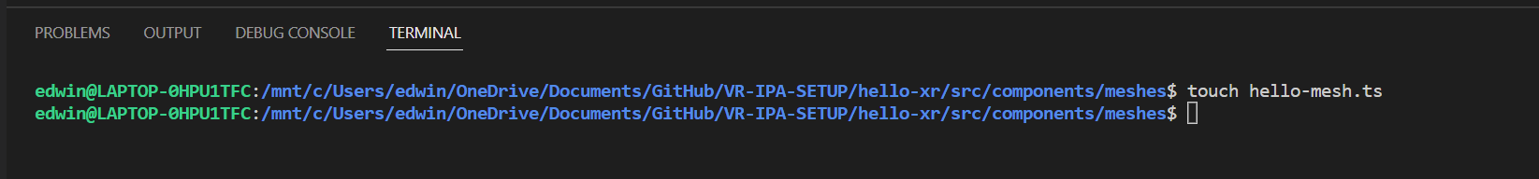

You should be able to see "hello-mesh.ts" file added to your "components\meshes" folder.

Change these codes under createScene() to:

//simple sphere

        const sphere = MeshBuilder.CreateSphere('sphere', { diameter: 1.3 }, scene)

        sphere.position.y = -0.5

        sphere.position.z = 5

        //hello sphere

        const helloSphere = new HelloSphere("hello sphere", {diameter: 1}, scene)

        helloSphere.position.set(0, 1, 5)

Go to **components\meshes\index.ts** and add the following codes:

export * from './hello-mesh'

Go to **components\meshes\hello-mesh.ts** and add the following codes:

import {

  AbstractMesh,

  Mesh,

  MeshBuilder,

  Scene,

  StandardMaterial,

} from "babylonjs";

import { TextPlane } from "./text-plane";

export interface HelloMesh {

  scene: Scene;

  mesh: Mesh;

  label: TextPlane;

}

export class HelloSphere extends AbstractMesh implements HelloMesh {

  scene: Scene;

  mesh: Mesh;

  label: TextPlane;

  constructor(name: string, options: { diameter: number }, scene: Scene) {

    super(name, scene);

    this.scene = scene;

    this.mesh = MeshBuilder.CreateSphere("hello sphere mesh", options, scene);

    this.mesh.material = new StandardMaterial("hello sphere material", scene);

    this.addChild(this.mesh);

    this.label = new TextPlane(

      "hello sphere label",

      1.5,

      1,

      0,

      options.diameter / 2 + 0.2,

      0,

      "hello sphere",

      "purple",

      "white",

      25,

      scene

    );

    this.addChild(this.label.mesh);

  }

}

**Check**

You should see 2 Spheres rendered in your web app.

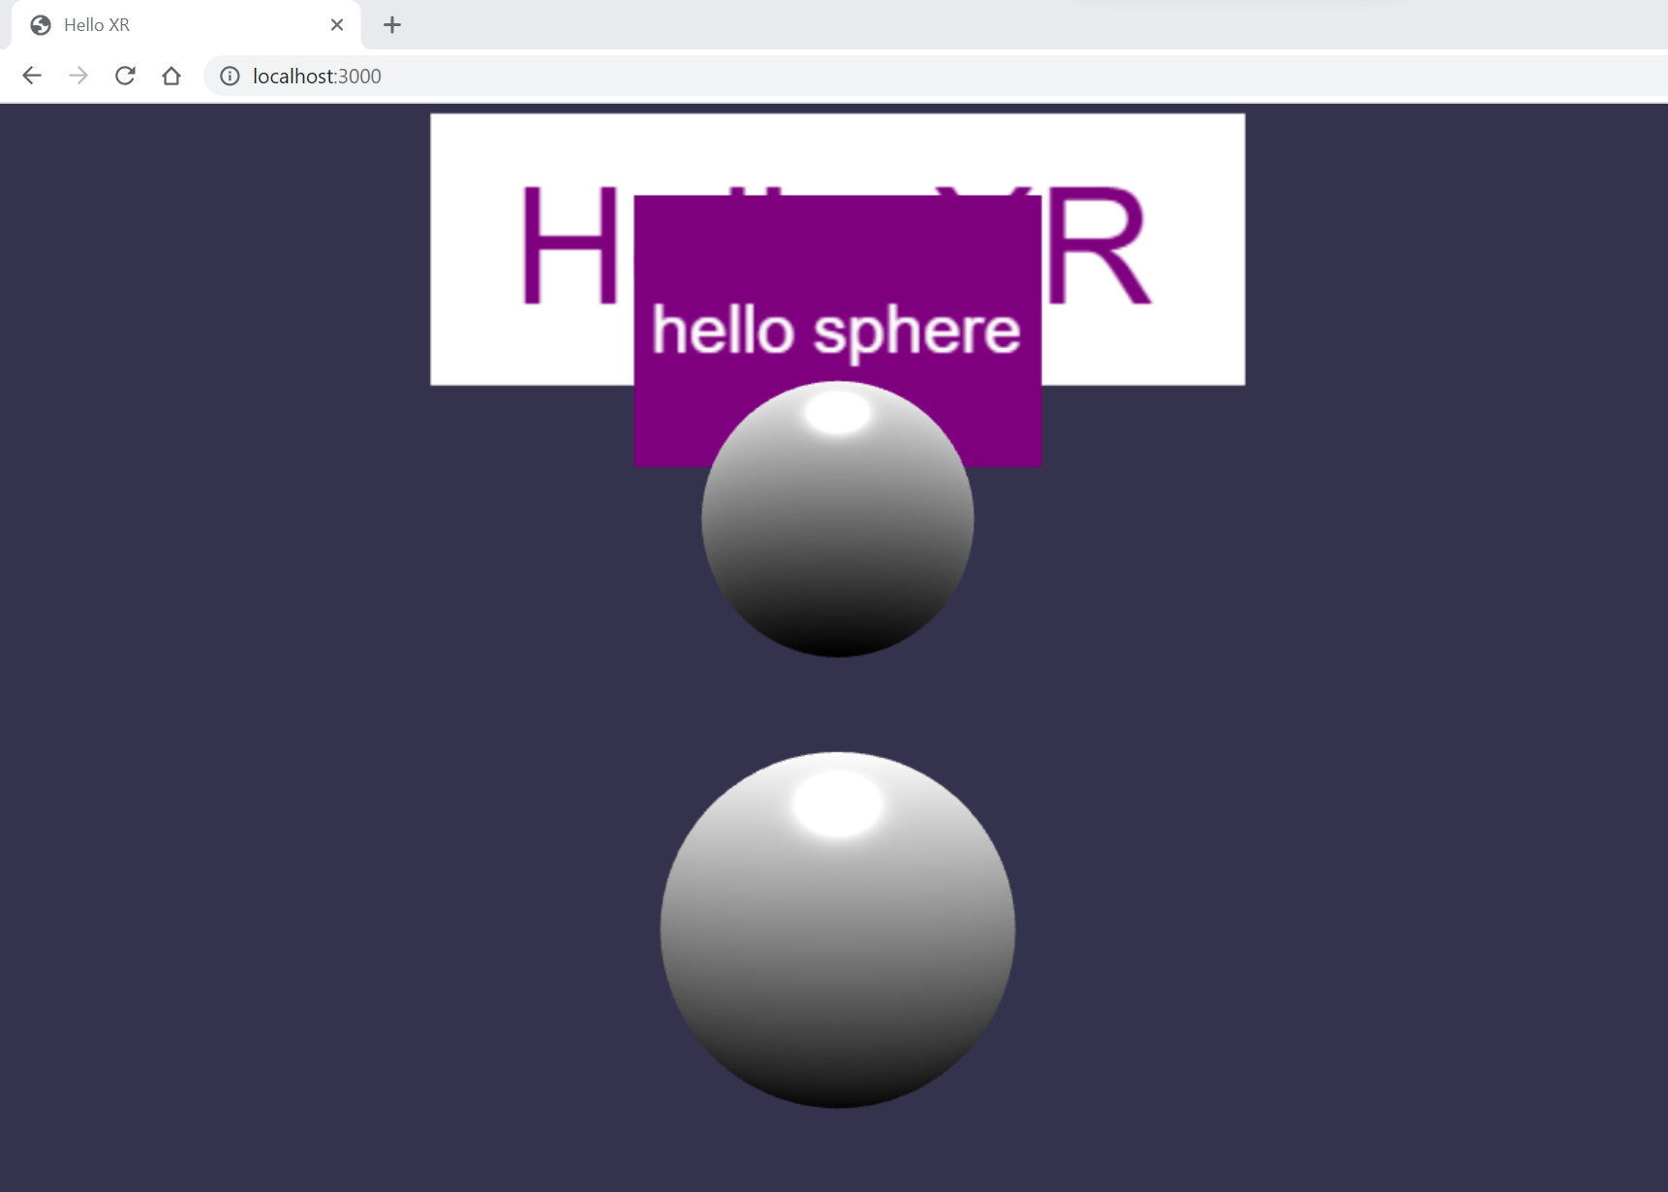

## Interactions